- Development timeline这张图丢失了
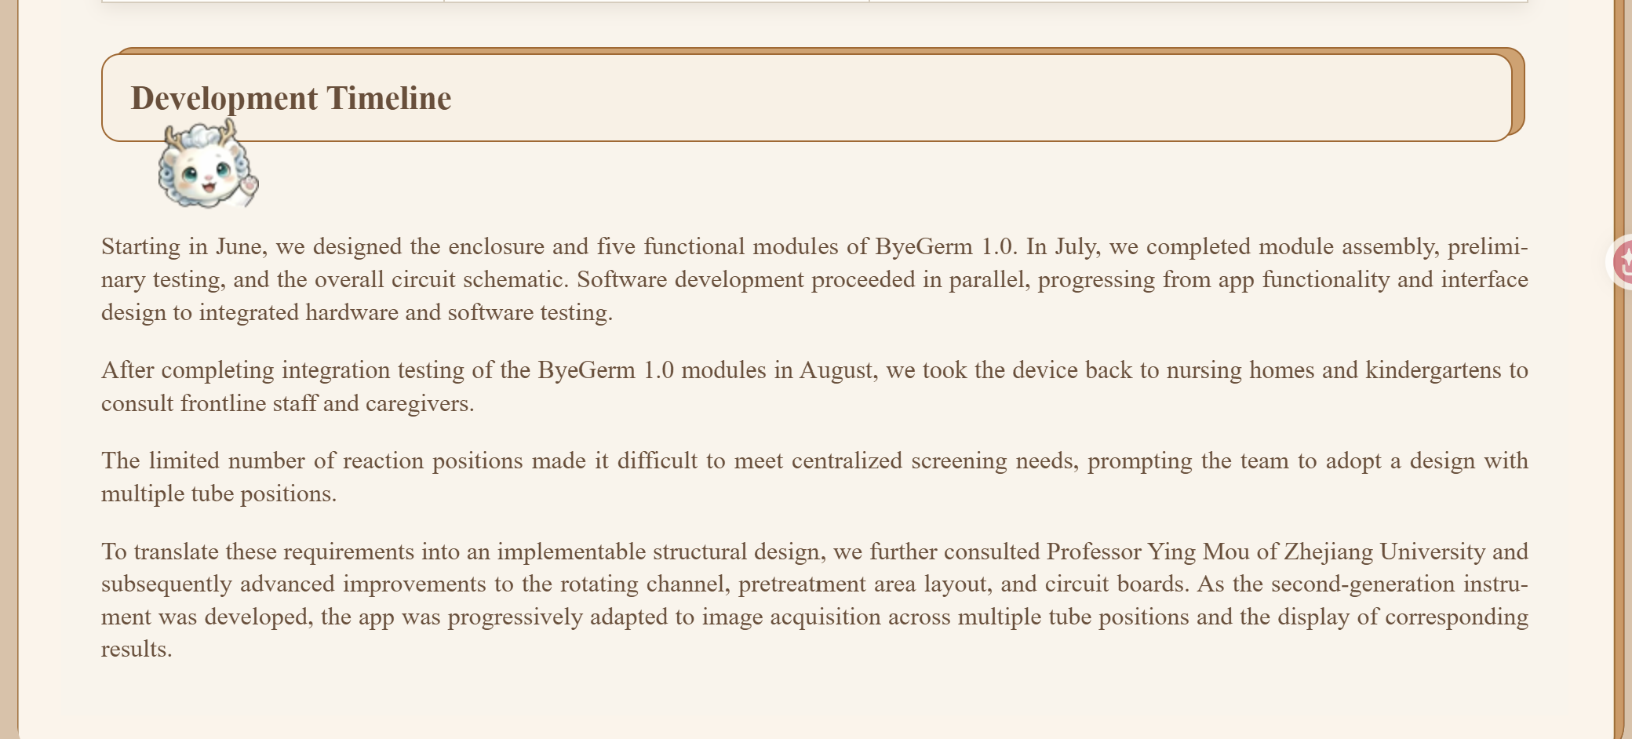
- Table 2缩小一些，可以在一个页面完全显示，不需要横向滑动
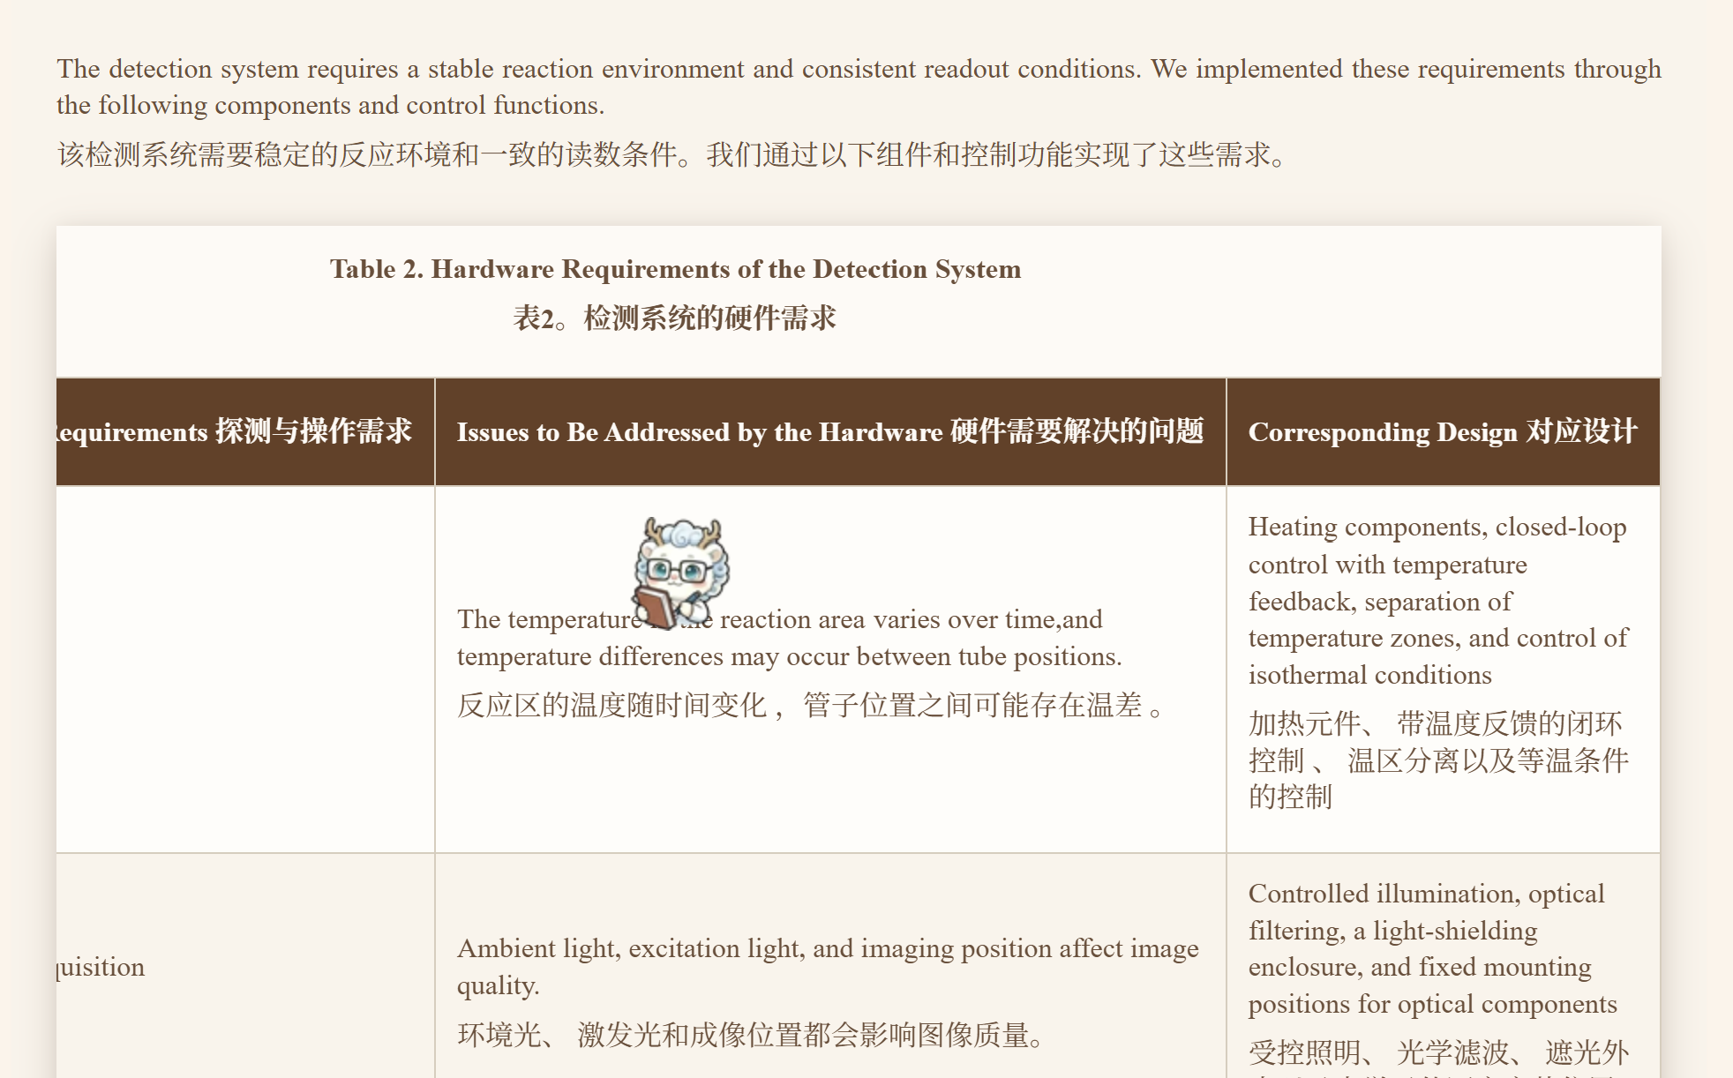
- Figure3图注修改为：
Figure 3. Photograph of the metal reaction tube support block, cooling fan, and optical filter components
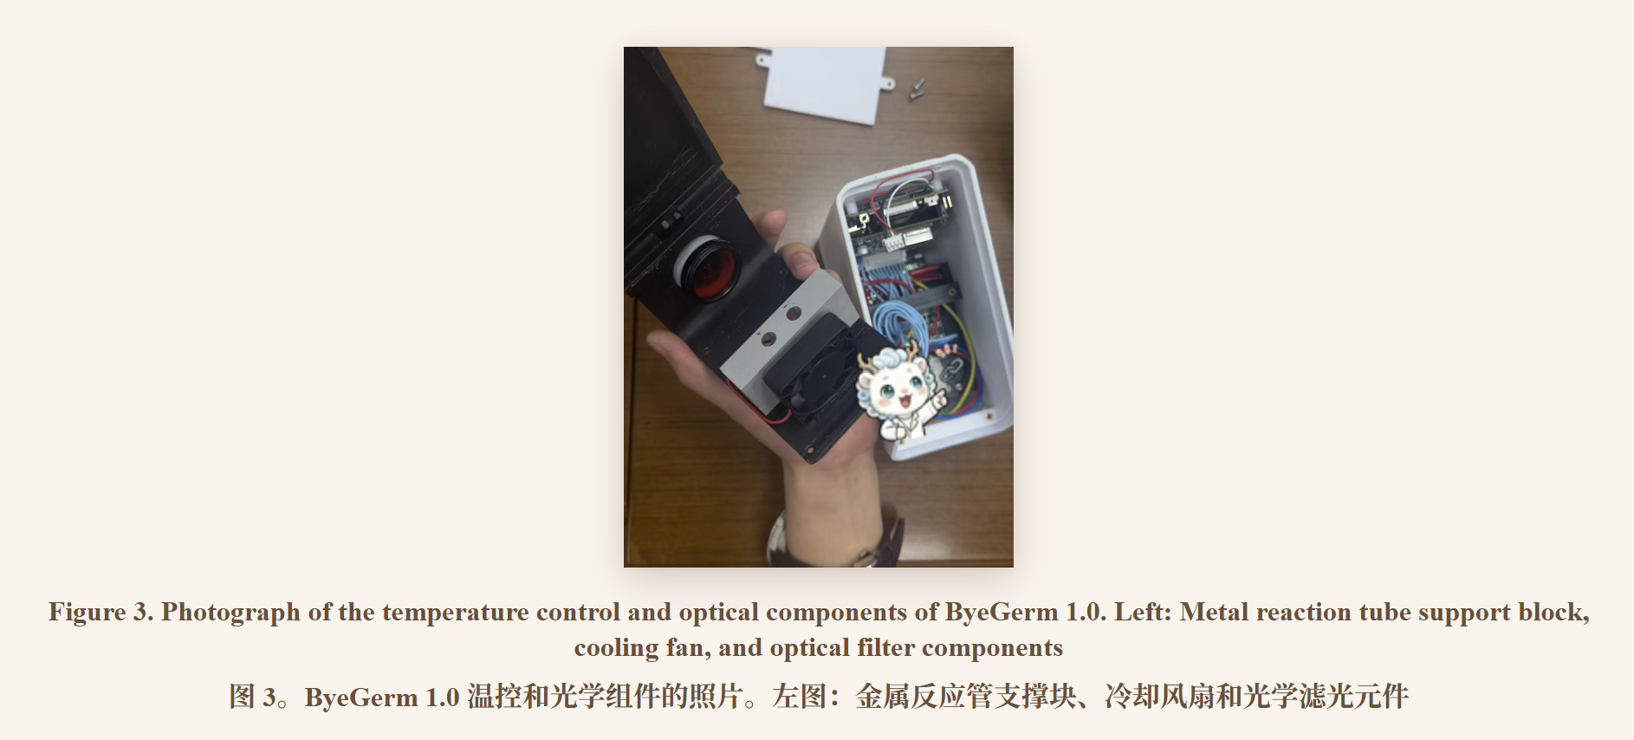
- 这句话删掉（fig8上面）
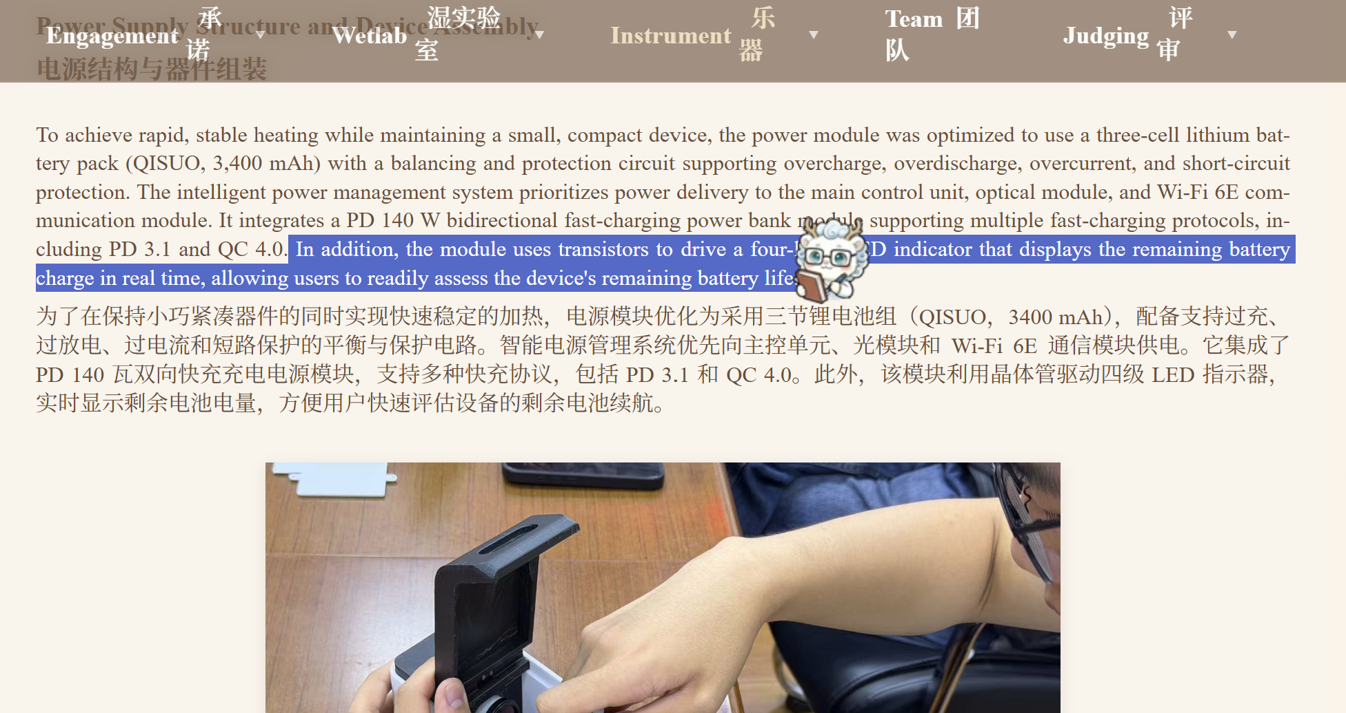
- Figure 9整张图片替换成：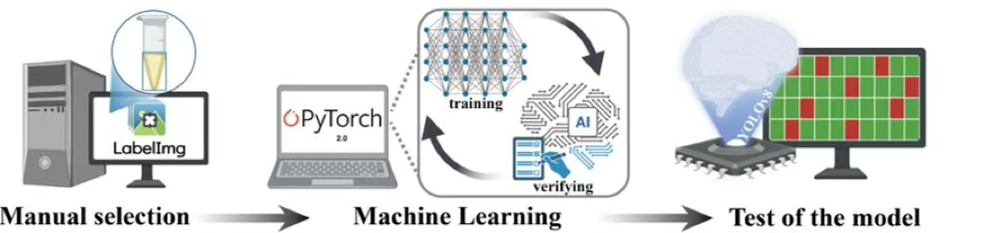
- Figure 9图注改为：Figure 9. Schematic of the image analysis workflow
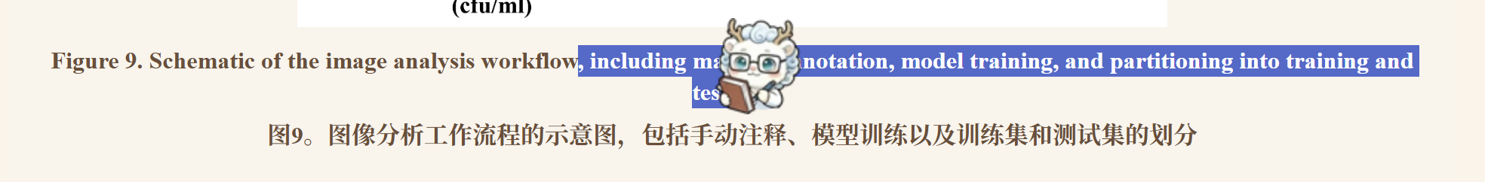
- 图里最上面那句话改成：
Detailed operating instructions are provided in the user manual .(Fig 11附近)
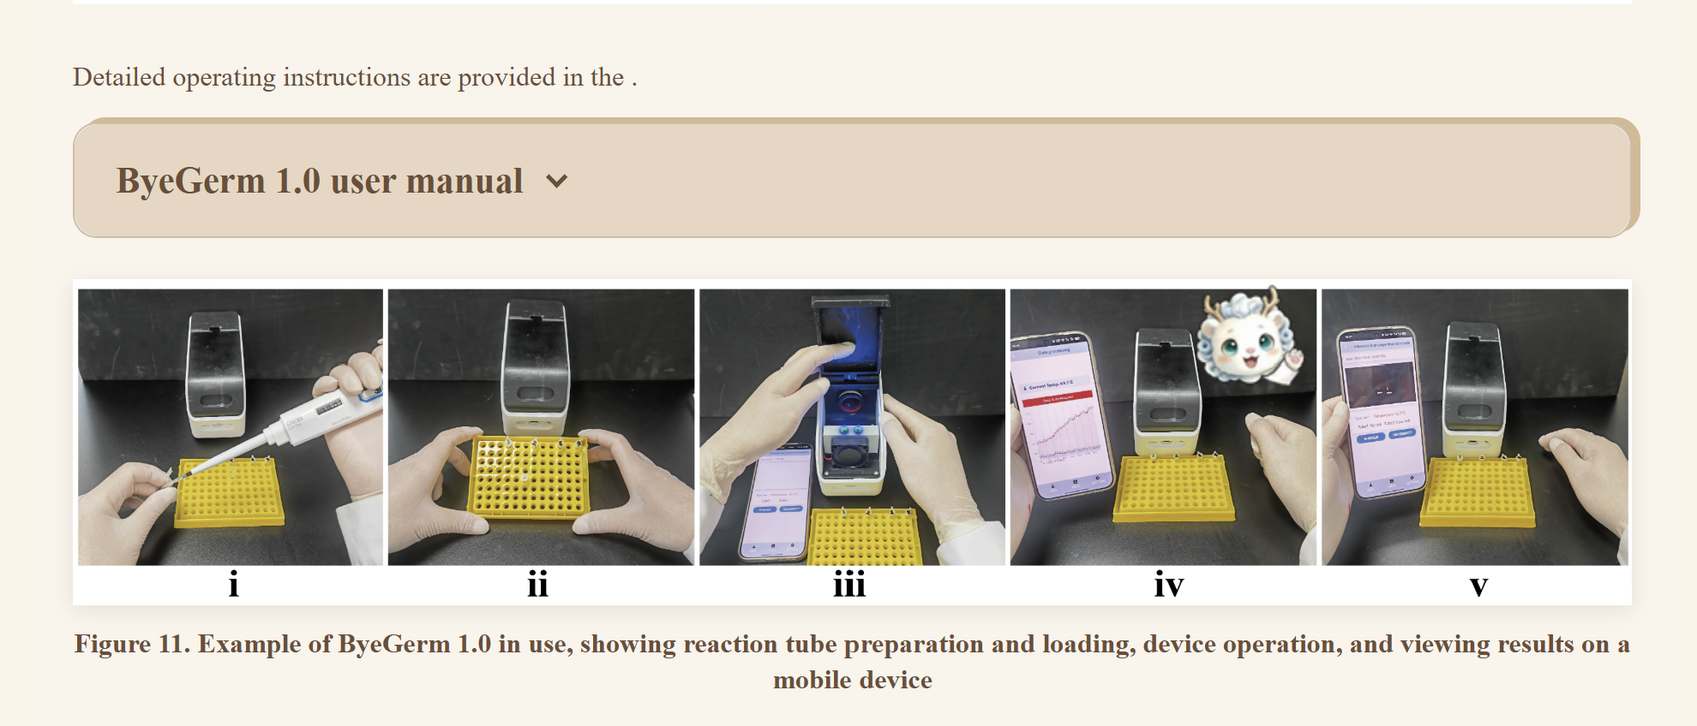
Further details are provided in the reproduction guide.（fig16附近）
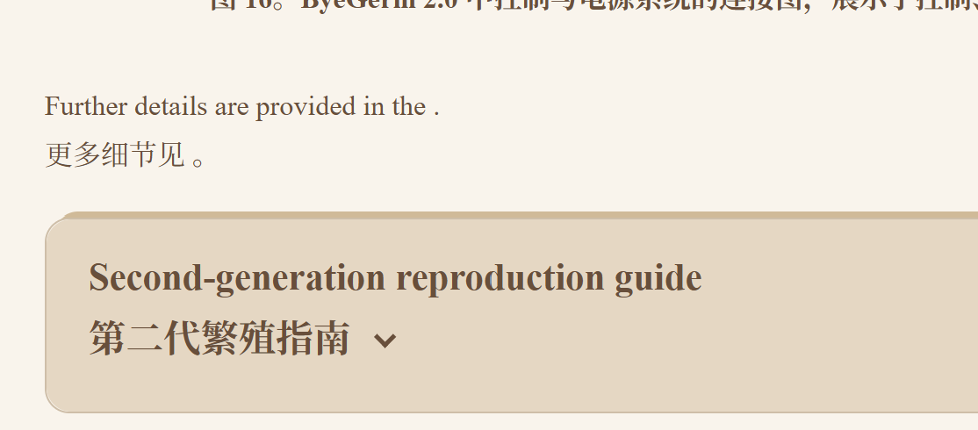
- 这张图加上图注,以及文字更改：（fig18附近）
Figure 19 .Operation proceeds through connection, loading, running the device, and viewing results.
Detailed operating instructions are provided in the user manual .
